Using TIC’s 3D-Printer
Up to date as of: Sept. 22, 2014
-Stuart Armstrong

Hardware requirements
- OS 10.7+ (if using a Mac)
- Windows 7+ (if using a PC)
- 2 GB RAM
- 220 MB of free space

Software Requirements
- MakerBot 3.2.2+ (for either Mac or PC): http://www.makerbot.com/desktop

File Requirements
- 3D object saved as .stl, .obj., .thing, .makerbot

Printing Parts on the MakerBot Replicator:
1. Open MakerBot program.
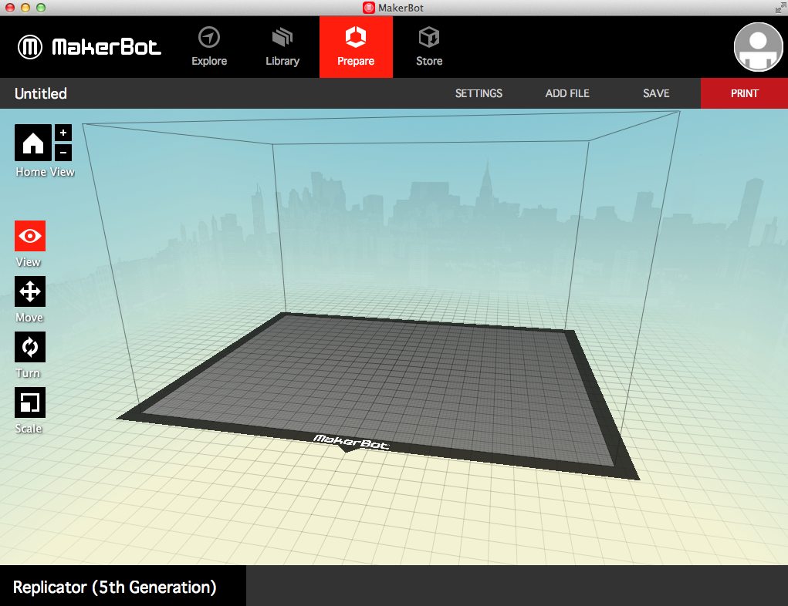

2. Click File -> Open -> {select desired file of type .stl, .obj, .thing, .makerbot}
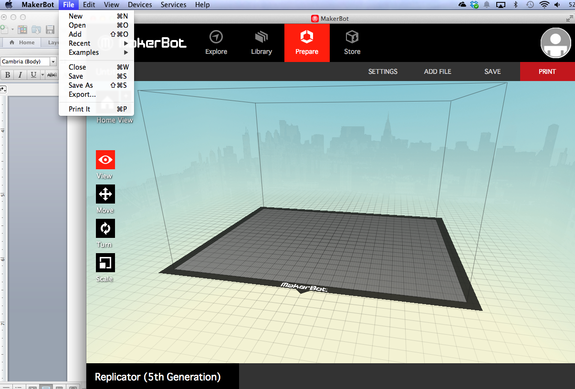

3. Orient your part on the simulated build platform.
- Click your part to highlight it.
- Click “Move”, “Turn”, or “Scale” to alter the position, orientation, or size of your part.
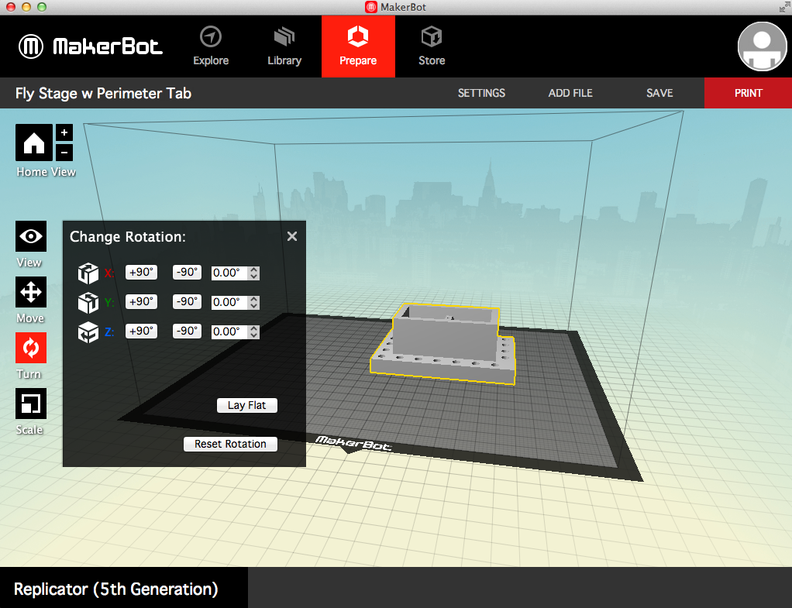

4. Once the part is situated, click “SETTINGS” and click on the “Standard” circle under the section labeled “Resolution:”. Click on the tab labeled “Speed” and set the extruding speed to 60 mm/s and the traveling speed to 90 mm/s. Click on the “Temperature” tab and set the temperature to 220°C.
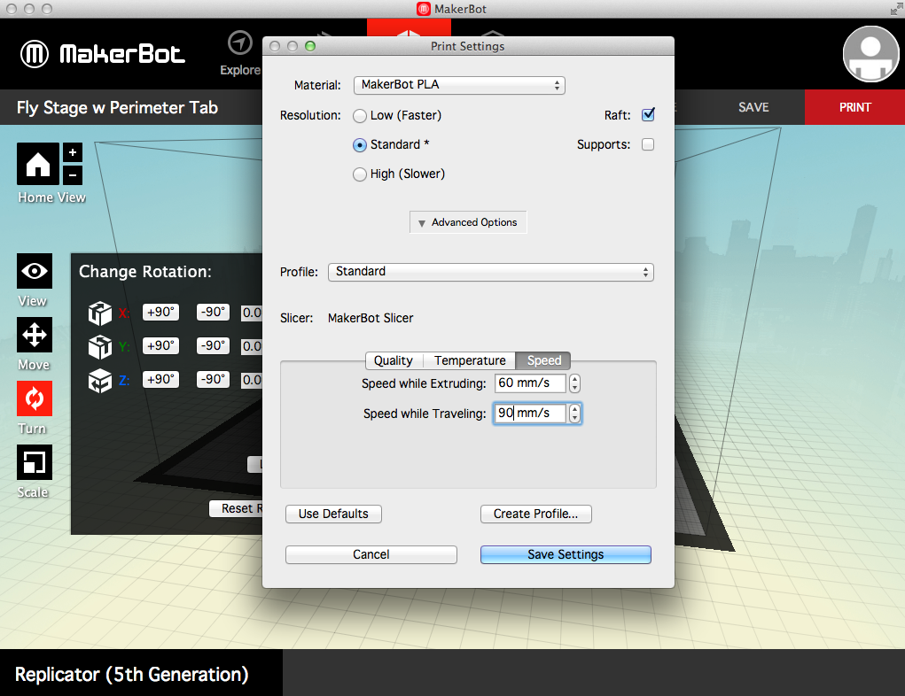

5. Plug the USB cable from the printer to your computer, and allow 60 seconds for your computer to recognize the printer.

6. Click “PRINT” in the top right corner.

7*. If available, watch the first few layers of the print to ensure a flat raft and smooth flow of the filament.

Advanced Options
1. After clicking “SETTINGS”, every parameter can be changed. Under “Quality”, “Infill” determines how solid your structure is, “Number of Shells” determines the wall thickness of the part, and “Layer Height” determines the z-resolution of the part.

2. Unchecking the “Raft” box means the part will print directly to the surface of the printer bed. This is NOT recommended. Checking the “Supports” box means any parts with features that hang over the bed’s surface will have thin supports printed that can later be removed and sanded smooth. This will increase the post-production by a few hours depending on the number of overhangs present.

